# Capstone Task 1

**Project Title: Academic Management System ( using SQL)**

## Database Creation

### Create the StudentInfo table with columns STU_ ID, STU_NAME, DOB, PHONE_NO,

### EMAIL_ID, ADDRESS.

CREATE TABLE StudentInfo (

STU_ID INT PRIMARY KEY,

STU_NAME VARCHAR(100),

DOB DATE,

PHONE_NO VARCHAR(15),

EMAIL_ID VARCHAR(100),

ADDRESS VARCHAR(255)

);

### Create the CoursesInfo table with columns COURSE_ID, COURSE_NAME, COURSE_INSTRUCTOR NAME

CREATE TABLE CoursesInfo (

COURSE_ID INT PRIMARY KEY,

COURSE_NAME VARCHAR(100),

COURSE_INSTRUCTOR_NAME VARCHAR(100)

);

### Create the EnrollmentInfo with columns ENROLLMENT_ID, STU_ ID, COURSE_ID,

### ENROLL_STATUS (Enrolled/Not Enrolled). The FOREIGN KEY constraint in the EnrollmentInfo table references the STU_ID column in the StudentInfo table and the COURSE_ID column in the CoursesInfo table.

CREATE TABLE EnrollmentInfo (

ENROLLMENT_ID INT PRIMARY KEY,

STU_ID INT,

COURSE_ID INT,

ENROLL_STATUS VARCHAR(20),

FOREIGN KEY (STU_ID) REFERENCES StudentInfo(STU_ID),

FOREIGN KEY (COURSE_ID) REFERENCES CoursesInfo(COURSE_ID)

);

## 2. Data Creation

### Insert some sample data for StudentInfo table , CoursesInfo table, EnrollmentInfo with

### respective fields.

For StudentInfo Table

INSERT INTO StudentInfo (STU_ID, STU_NAME, DOB, PHONE_NO, EMAIL_ID, ADDRESS) VALUES

(1, 'Alice Smith', '1998-05-12', '123-456-7890', 'alice.smith@example.com', '123 Maple Street'),

(2, 'Bob Johnson', '1997-08-23', '234-567-8901', 'bob.johnson@example.com', '456 Oak Avenue'),

(3, 'Charlie Davis', '1999-12-02', '345-678-9012', 'charlie.davis@example.com', '789 Pine Road'),

(4, 'Diana Evans', '2000-03-15', '456-789-0123', 'diana.evans@example.com', '101 Birch Lane'),

(5, 'Eve Foster', '1998-07-29', '567-890-1234', 'eve.foster@example.com', '202 Cedar Boulevard');

For CourseInfo Table

INSERT INTO CoursesInfo (COURSE_ID, COURSE_NAME, COURSE_INSTRUCTOR_NAME) VALUES

(101, 'Mathematics', 'Dr. Alan Turing'),

(102, 'Physics', 'Dr. Marie Curie'),

(103, 'Chemistry', 'Dr. Rosalind Franklin'),

(104, 'Biology', 'Dr. Charles Darwin'),

(105, 'Computer Science', 'Dr. Ada Lovelace');

For EnrollmentInfo Table

INSERT INTO EnrollmentInfo (ENROLLMENT_ID, STU_ID, COURSE_ID, ENROLL_STATUS) VALUES

(1, 1, 101, 'Enrolled'),

(2, 1, 102, 'Enrolled'),

(3, 2, 103, 'Not Enrolled'),

(4, 2, 104, 'Enrolled'),

(5, 3, 105, 'Enrolled'),

(6, 3, 101, 'Not Enrolled'),

(7, 4, 102, 'Enrolled'),

(8, 4, 103, 'Enrolled'),

(9, 5, 104, 'Not Enrolled'),

(10, 5, 105, 'Enrolled');

## 3. Retrieve the Student Information

### a. Write a query to retrieve student details, such as student name, contact informations, and Enrollment status.

Query:

SELECT

SI.STU_NAME

,SI.PHONE_NO

,SI.EMAIL_ID

,SI.ADDRESS

,EI.COURSE_ID

,ENROLL_STATUS

FROM StudentInfo SI

INNER JOIN EnrollmentInfo EI

ON SI.STU_ID = EI.STU_ID

Output:

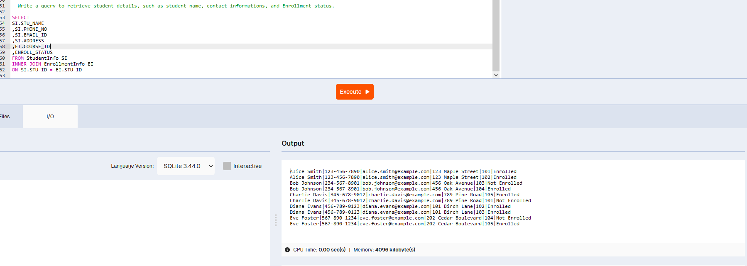

### b. Write a query to retrieve a list of courses in which a specific student is enrolled.

Query:

SELECT

CI.COURSE_ID

, CI.COURSE_NAME

, CI.COURSE_INSTRUCTOR_NAME

FROM CoursesInfo CI

JOIN

EnrollmentInfo EI ON CI.COURSE_ID = EI.COURSE_ID

JOIN

StudentInfo SI ON EI.STU_ID = SI.STU_ID

WHERE

SI.STU_NAME = 'Alice Smith' AND EI.ENROLL_STATUS = 'Enrolled';

Output:

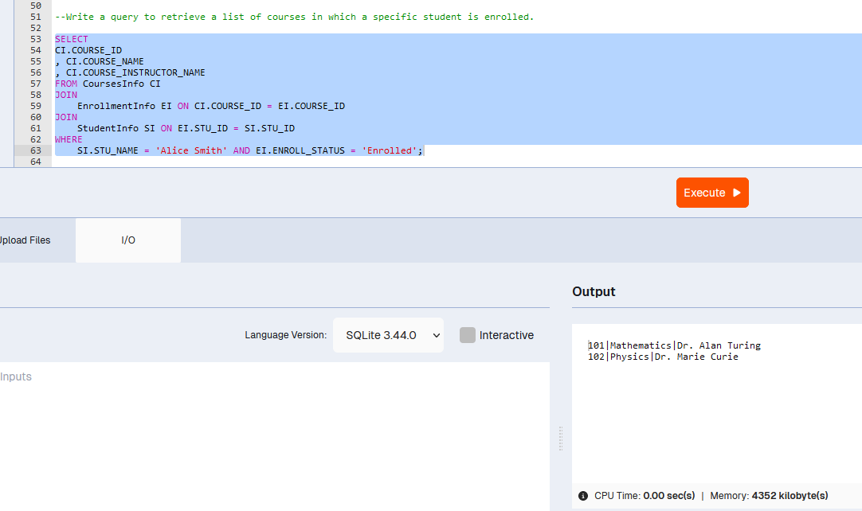

### Write a query to retrieve course information, including course name, instructor information.

Query:

SELECT

COURSE_ID

, COURSE_NAME

, COURSE_INSTRUCTOR_NAME

FROM CoursesInfo ;

Output:

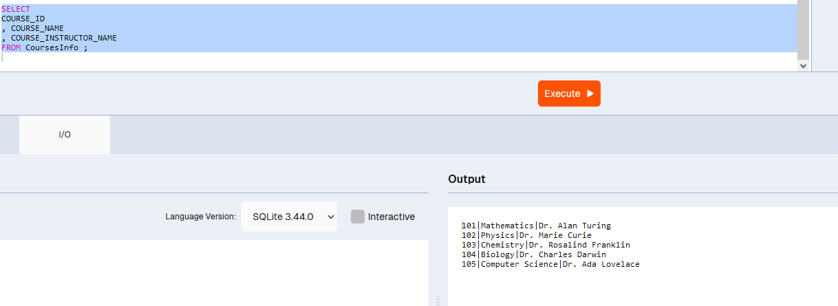

### Write a query to retrieve course information for a specific course

Query:

SELECT

COURSE_ID

, COURSE_NAME

, COURSE_INSTRUCTOR_NAME

FROM CoursesInfo

WHERE COURSE_ID = 101;

OR

SELECT

COURSE_ID

, COURSE_NAME

, COURSE_INSTRUCTOR_NAME

FROM CoursesInfo

WHERE COURSE_NAME = 'Mathematics';

Output:

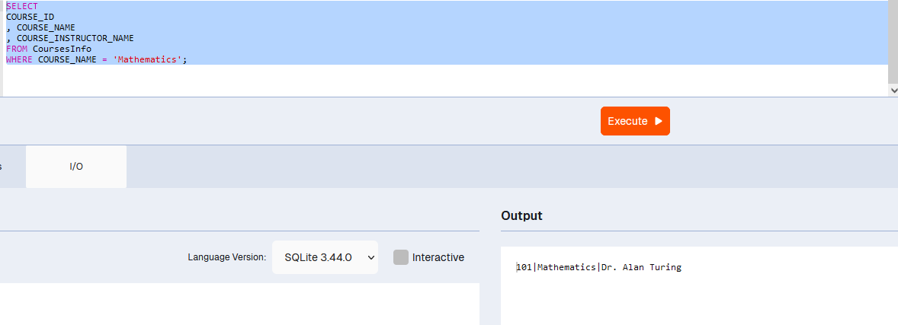

### Write a query to retrieve course information for multiple courses

Query:

Using Course id

SELECT

COURSE_ID

, COURSE_NAME

, COURSE_INSTRUCTOR_NAME

FROM CoursesInfo

WHERE COURSE_ID IN (101, 102, 103) ;

OR

Using Course name

SELECT

COURSE_ID

, COURSE_NAME

, COURSE_INSTRUCTOR_NAME

FROM CoursesInfo

WHERE COURSE_NAME IN ('Mathematics', 'Physics', 'Chemistry') ;

Output:

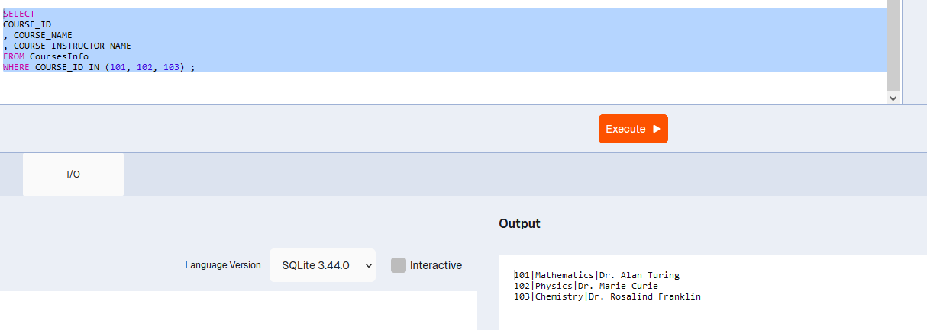

## Reporting and Analytics (Using joining queries)

### Write a query to retrieve the number of students enrolled in each course

Query:

SELECT

CI.COURSE_ID

,CI.COURSE_NAME

,COUNT(EI.STU_ID) AS NO_OF_STUDENT

FROM CoursesInfo CI

JOIN EnrollmentInfo EI ON EI.COURSE_ID = CI.COURSE_ID

WHERE EI.ENROLL_STATUS = 'Enrolled'

GROUP BY CI.COURSE_ID,CI.COURSE_NAME ;

Output:

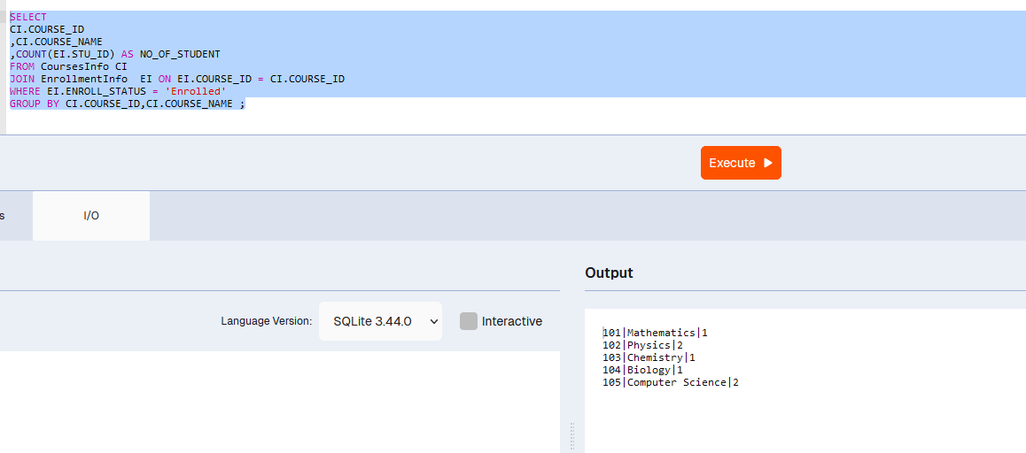

### Write a query to retrieve the list of students enrolled in a specific course

QUERY:

Using Course name

SELECT

s.STU_ID,

s.STU_NAME,

s.PHONE_NO,

s.EMAIL_ID,

s.ADDRESS

FROM CoursesInfo CI

JOIN EnrollmentInfo EI ON EI.COURSE_ID = CI.COURSE_ID

JOIN StudentInfo s ON s.STU_ID = EI. STU_ID

WHERE EI.ENROLL_STATUS = 'Enrolled' AND CI. COURSE_NAME = 'Mathematics';

Using Course id

SELECT

s.STU_ID,

s.STU_NAME,

s.PHONE_NO,

s.EMAIL_ID,

s.ADDRESS

FROM

StudentInfo s

JOIN

EnrollmentInfo e ON s.STU_ID = e.STU_ID

WHERE

e.COURSE_ID = 101 AND e.ENROLL_STATUS = 'Enrolled';

Output:

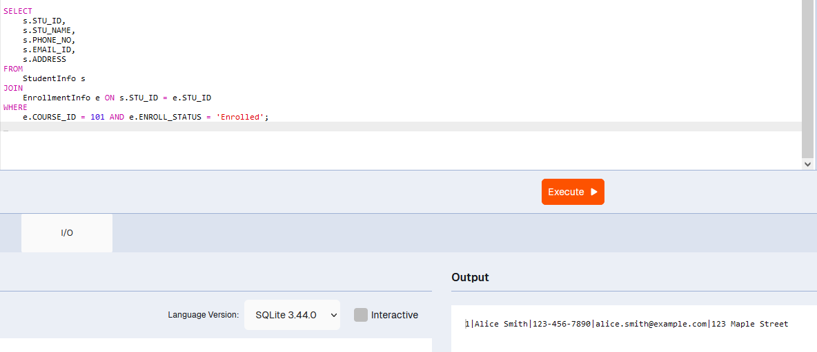

### Write a query to retrieve the count of enrolled students for each instructor.

QUERY:

SELECT

c.COURSE_INSTRUCTOR_NAME

, COUNT(s.STU_ID) AS STUDENT_COUNT

FROM

StudentInfo s

JOIN

EnrollmentInfo e ON s.STU_ID = e.STU_ID

JOIN

CoursesInfo c ON e.COURSE_ID = c.COURSE_ID

WHERE

e.ENROLL_STATUS = 'Enrolled'

GROUP BY 1;

Output:

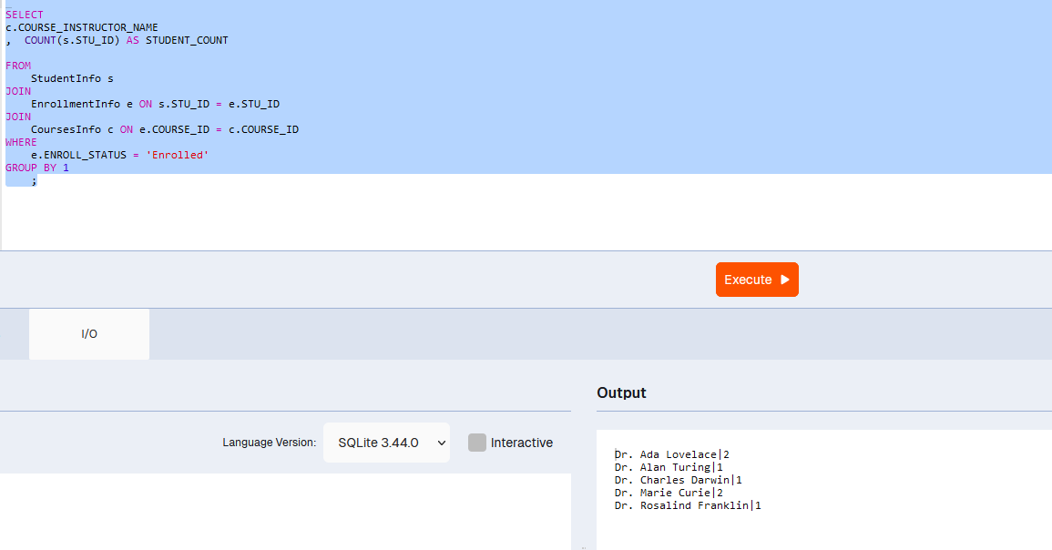

### Write a query to retrieve the list of students who are enrolled in multiple courses

QUERY:

SELECT

s.STU_ID,

s.STU_NAME,

s.PHONE_NO,

s.EMAIL_ID,

s.ADDRESS

FROM

StudentInfo s

JOIN

EnrollmentInfo e ON s.STU_ID = e.STU_ID

JOIN

CoursesInfo c ON e.COURSE_ID = c.COURSE_ID

WHERE

e.ENROLL_STATUS = 'Enrolled' AND c.COURSE_ID IN (101, 102,103)

Output:

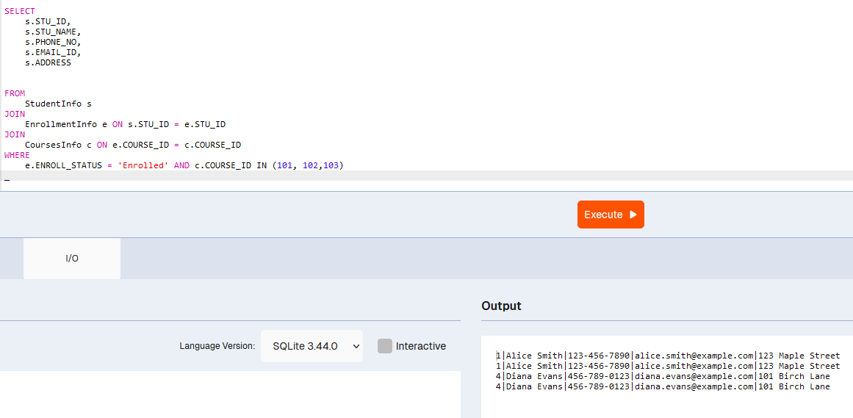

### Write a query to retrieve the courses that have the highest number of enrolled students (arranging from highest to lowest)

QUERY:

SELECT

c. COURSE_ID

, c.COURSE_NAME

, COUNT (s.STU_ID) AS STUDENT_COUNT

FROM

StudentInfo s

JOIN

EnrollmentInfo e ON s.STU_ID = e.STU_ID

JOIN

CoursesInfo c ON e.COURSE_ID = c.COURSE_ID

WHERE

e.ENROLL_STATUS = 'Enrolled'

GROUP BY 1,2

ORDER BY COUNT (s.STU_ID) DESC

Output:

